**Proposed Project Title:** Smart quiz generation Web App

* Planning To create firstly WebApp then having in mind to build mobile app.
* But trying to make webapp mobile friendly so we do not need mobile app.
* Quiz App Takes Scanned Images or digital Pdfs and converts them into excel sheet format(to structured data).
* In Excel sheet Format like below:

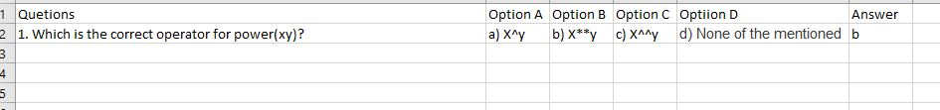

So we can easily store this structure data to our database.

**New Proposed Features:**

* Proctate mode( facial recognition, capturing photos after some interval of time, real time video recording of candidate)
* ID Card Detection or face detection varification beafore exam.
* Real time in frame candidate detection(tracing candidate movement in real time and gives warnnings if candidate move outside frame)
* Also Check there are other persons in frame or not.
* Scrapping random mcqs from other websites.

**Resourses:**

<https://www.geeksforgeeks.org/extract-text-from-pdf-file-using-python/>

<https://opencv.org/>

**Extracting Pdf data to Excel Files:**

<https://docparser.com/blog/extract-data-from-pdf/>

<https://pythoninoffice.com/pdf-to-excel-with-python/>

**Medium Artical on Python for Pdf**

<https://medium.com/@umerfarooq_26378/python-for-pdf-ef0fac2808b0>

**Technologies Proposed to Used:**

**For Web App-** Django Framework

**Front End Of Website :** Html,Css,JavaScript .

**Backend:** Python

**Image Processing:** Computer Vision Libary(OpenCV)

**Database:** MySQL or SQLITE 3 or MongoDB

**Version Control:** Git Hub and Git

**Initial Problem Statement:** Smart quiz generation system

In the online education mode conducting MCQ based quiz is widely used. A system which reads the questions and answers from the hard copy document and converts it into digital form is to be developed. The application may read the text from word or pdf document and converts it into digital form. A complete mobile and web application is to be developed with the support for taking the online MCQ based quiz.